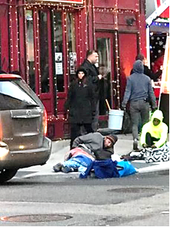  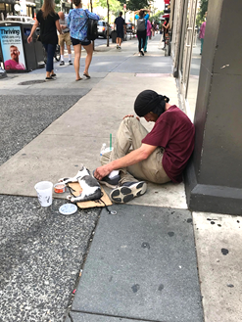  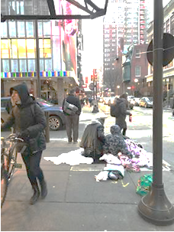  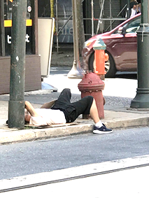 | WHAT YOU CAN DO…  WHEN THE HOMELESS, PANHANDLERS, CHRONIC LOITERERS,  & THE MENTALLY ILL CAMP OUT ON YOUR SIDEWALK.  Businesses, property owners, and tenants have the legal ‘right & responsibility’ to keep their sidewalk and the vicinity around their business or property free from “prohibited conduct” under PA Title 18 Sec. 3503, and Titles 9-4400 & 10-600 of the Philadelphia Code.  When people are repeatedly sitting or lying on your sidewalk, panhandling, or loitering in front of your business, you can do the following:  - Ask and or demand the person(s) to leave, which is the easiest and most effective thing to do in most situations.  - Call 911. The police will call the Homeless Outreach Team, if necessary.  If the police do not successfully move and/or cite the individual(s), then ask to speak to the police supervisor.  - Contact your local Police District, if the problem persists, and ask to speak  to the District Captain: http://www.phillypolice.com/districts  - Contact the Police Commissioner: Police.Commissioner@phila.gov /  215-686-3280  - Contact Mayor James Kenney: James.Kenney@Phila.Gov / 215-686-2181  - Contact your city councilmember: safestreetsphilly.org/WhatYouCanDo.htm  - ‘Press charges’ with the police, particularly against those who are chronic offenders. This takes more time on your part, but may be the most effective way to prevent re-occurrences.  Other Things You Can Do: If your business has an alcove, install a gate to bar access at night. Intensive landscaping can also be employed to deter prohibited conduct. Keep your business litter-free. Remove from public view and public access all trash and recycling containers, particularly commercial dumpsters.  What about the rights of the homeless? Ethics and morality dictate that everyone should have shelter. Under the latest federal court ruling (Martin v City of Boise), the homeless have no right to sleep on the streets as long as government provides shelter space. That is why it is vital that Philadelphia always provide shelter space for the homeless. Government-guaranteed shelter and services for those in need is an essential safety net for the health and wellbeing of our entire society.  Learn more at SafeStreetsPhilly.org

